

22

CSL

51

-

IOT & Cloud



Computing



**DIESEL THEFT DETECTION IN HEAVY VEHICLES**

Chandru K(23CSR037)

Danush P (23CSR038)

Dharun Siddharth S P (23CSR049)

Dinu Anand C R (23CSR055)

**1. Abstract**

**ChatGPT said:**

**The Fuel Theft Detection System is an IoT-based solution designed to detect and prevent unauthorized fuel drainage from vehicle or storage tanks. It uses an ultrasonic sensor with an ESP32 microcontroller to measure fuel levels and send real-time data to the Blynk IoT platform. A sudden drop beyond a predefined threshold triggers a buzzer alarm and sends instant alerts to the user’s smartphone. Through a Wi-Fi connection, users can remotely monitor fuel levels and receive notifications via the Blynk dashboard. This system provides a smart, cost-effective, and efficient way to ensure fuel security and management.**

**Design Methodology**

The **Fuel Theft Detection System** works by continuously monitoring the fuel level using an ultrasonic sensor and sending alerts through the Blynk IoT platform when abnormal changes are detected.

1. **Sensor Setup:**  
   The ultrasonic sensor is placed above the fuel tank to measure the fuel level by calculating the distance between the sensor and the fuel surface.
2. **Data Processing:**  
   The ESP32 microcontroller reads the sensor data and calculates the current fuel level. It compares the current reading with the initial calibrated level.
3. **Theft Detection:**  
   If the fuel level drops suddenly beyond a preset threshold, the system detects it as possible fuel theft.
4. **Alert System:**  
   When theft is detected, a buzzer is activated for a local alert, and a notification is sent to the user via the **Blynk mobile app**.
5. **Monitoring:**  
   The fuel level and alerts are displayed in real-time on the Blynk dashboard, allowing users to monitor the tank remotely.

**Components Required**

* **ESP32 Development Board – Acts as the main controller and handles Wi-Fi communication.**
* **Ultrasonic Sensor (HC-SR04) – Measures the fuel level by calculating the distance to the fuel surface.**
* **GSM Module:** Sends SMS alerts with coordinates to emergency contacts.
* **Power Supply (5V / USB Cable) – Powers the ESP32 and sensor.**
* **Smartphone with Blynk App – Displays real-time fuel levels and receives alert notifications.**
* **Wi-Fi Network** – Enables ESP32 to connect to the Blynk cloud for IoT communication.

**Circuit Diagram:**

* **Accelerometer:** Connected to Arduino analogy pins (for impact detection).
* **GPS Module:** TX/RX connected to digital pins (for location data).
* **GSM Module:** TX/RX connected to separate digital pins (for message communication).
* **Buzzer:** Positive terminal to pin D8, negative to GND.
* **LED with 220Ω Resistor:** Anode connected to D9 via resistor, cathode to GND.
* **Power Supply:** 9V battery or USB power input to Arduino.

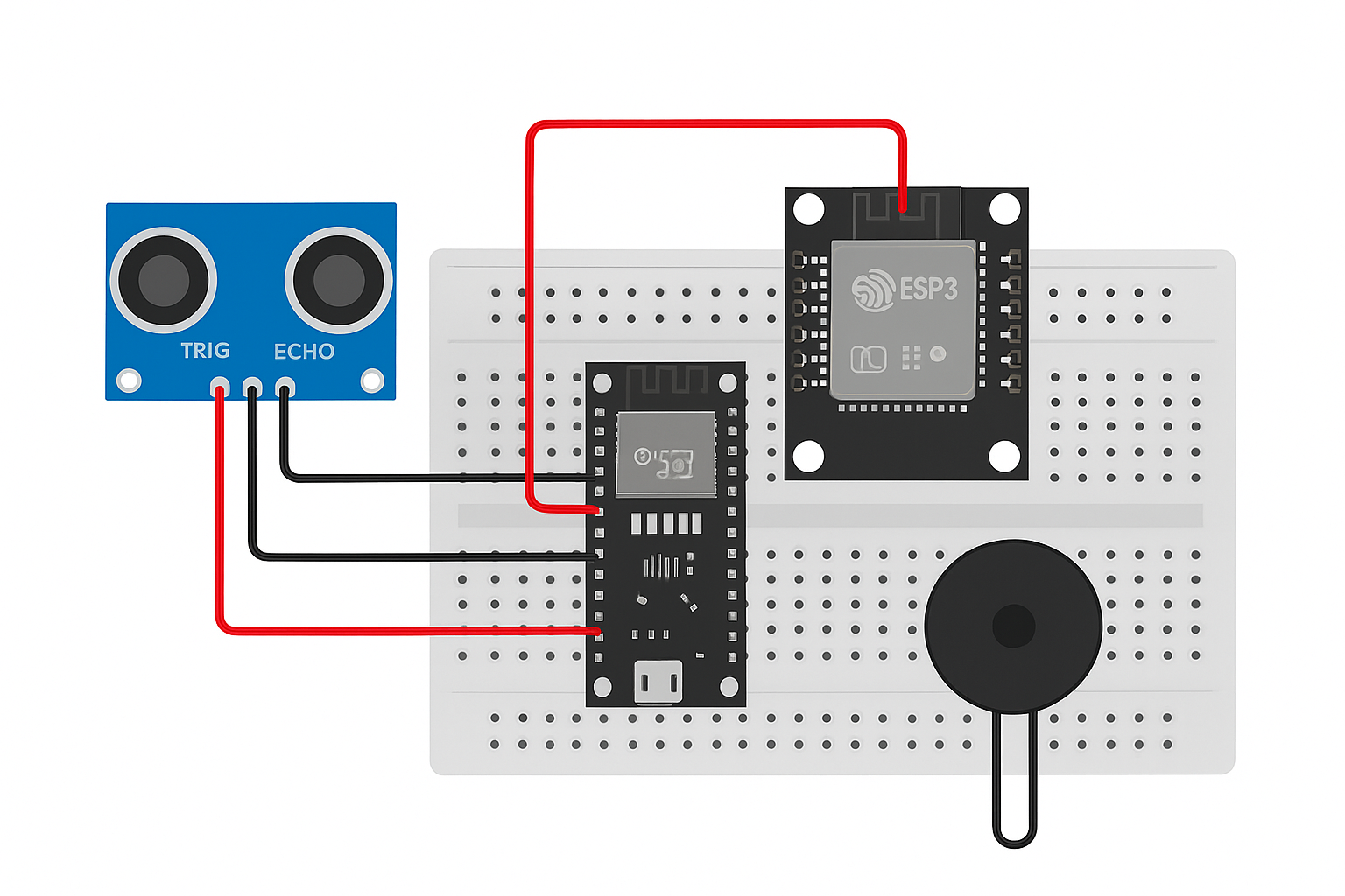

**Coding:**

#define BLYNK_PRINT Serial

#include <WiFi.h>

#include <BlynkSimpleEsp32.h>

// Blynk Template Name

#define BLYNK_TEMPLATE_NAME "Fuel Theft Detector"

// Blynk Auth Token (IoT)

#define BLYNK_AUTH_TOKEN "wTBnagSMicUQSlMnRlNMLhhYKfCoHFBm"

// Wi-Fi credentials

char ssid[] = "Galaxy S24 Ultra 860C";

char pass[] = "123456789";

// Ultrasonic Sensor Pins

#define TRIG_PIN 5

#define ECHO_PIN 18

#define BUZZER_PIN 19

// Variables

long duration;

float distance;

float initialLevel = 0;

float currentLevel = 0;

float threshold = 2.0; // Allowed difference in cm

bool alertSent = false;

BlynkTimer timer;

// Function to measure distance

float getDistance() {

digitalWrite(TRIG_PIN, LOW);

delayMicroseconds(2);

digitalWrite(TRIG_PIN, HIGH);

delayMicroseconds(10);

digitalWrite(TRIG_PIN, LOW);

duration = pulseIn(ECHO_PIN, HIGH);

float dist = (duration * 0.0343) / 2; // Convert to cm

return dist;

}

// Function to check fuel level and trigger alerts

void checkFuelLevel() {

currentLevel = getDistance();

Serial.print("Current Level: ");

Serial.print(currentLevel);

Serial.println(" cm");

// Send data to Blynk dashboard (V0)

Blynk.virtualWrite(V0, currentLevel);

// Detect abnormal drop (fuel theft)

if (initialLevel - currentLevel > threshold) {

Serial.println("⚠️ Fuel level decreased! Possible theft detected!");

digitalWrite(BUZZER_PIN, HIGH);

if (!alertSent) {

Blynk.logEvent("fuel_theft", "Fuel level dropped! Possible theft detected!");

alertSent = true; // avoid spamming

}

} else {

digitalWrite(BUZZER_PIN, LOW);

alertSent = false;

}

}

void setup() {

Serial.begin(115200);

pinMode(TRIG_PIN, OUTPUT);

pinMode(ECHO_PIN, INPUT);

pinMode(BUZZER_PIN, OUTPUT);

Serial.println("Starting ESP32...");

// Connect to Wi-Fi

WiFi.begin(ssid, pass);

Serial.print("Connecting to Wi-Fi");

int attempts = 0;

while (WiFi.status() != WL_CONNECTED && attempts < 20) {

delay(500);

Serial.print(".");

attempts++;

}

if (WiFi.status() == WL_CONNECTED) {

Serial.println("\nWi-Fi connected!");

Serial.print("IP Address: ");

Serial.println(WiFi.localIP());

} else {

Serial.println("\nFailed to connect to Wi-Fi.");

}

// Connect to Blynk IoT server

Blynk.begin(BLYNK_AUTH_TOKEN, ssid, pass, "blynk.cloud", 80);

// Calibrate initial fuel level

Serial.println("Calibrating initial fuel level...");

delay(2000);

float total = 0;

for (int i = 0; i < 10; i++) {

total += getDistance();

delay(200);

}

initialLevel = total / 10;

Serial.print("Initial Fuel Level (cm): ");

Serial.println(initialLevel);

// Send initial calibration value to Blynk (V1)

Blynk.virtualWrite(V1, initialLevel);

// Setup timer to check fuel level every second

timer.setInterval(1000L, checkFuelLevel);

}

void loop() {

Blynk.run();

timer.run();

}**O/P Screenshot:**

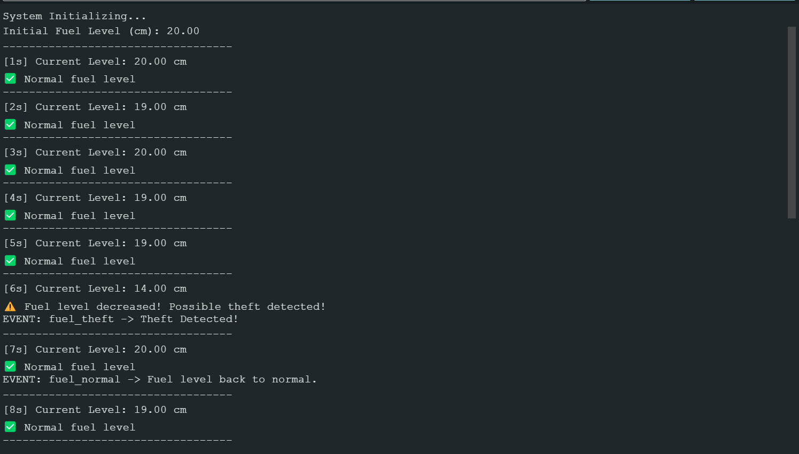

**Conclusion:**

The Fuel Theft Detection System offers an efficient and reliable way to monitor fuel levels and detect theft in real time. Using an ultrasonic sensor, ESP32 microcontroller, and Blynk IoT platform, it provides both buzzer alerts and smartphone notifications. The system ensures accurate measurement, quick alerts, and easy monitoring through the Blynk dashboard, making it a cost-effective and practical solution for vehicles and storage tanks.